Code Quality or Code Review

-> Code Review is the process of verifying coding standards followed by developers in coding.

-> Code Review is used to identify the coding problems in the code

-> Using Code Review we can easily identify the mistakes we have done in our source code and we can fix them

-> Using Code Review we can improve code quality and our coding skills will be improved

-> Have we written any duplicate code, whether a declared variable is not used , whether a defined method is not called, not checking the nulls properly, , not handling the exceptions properly, - such kind of problems in the code will be identified by the Code Review

-> In real-time Code Review will happen in 2 ways

1) Automated Review using Tool
2) Peer Review

Java Code Quality Tools
Google for “Java Code Quality Tools”
https://www.javacodegeeks.com/2012/10/java-code-quality-tools-overview.html

1. CodePro Analytix 2. PMD 3. FindBugs 4. Cobertura 5. SonarQube etc

-> We will use SonarQube server to perform code review. It will verify our source code and it will identify problems in our code.

Note: Sonar Qube will not check logic of the program is correct or not.

-> Peer Review is the process of verifying logic of the program. Junior developers logic will be verified by senior developers in the project.

What is SonarQube?

-> SonarQube software is used to perform Code Review Google for "SonarQube"

-> SonarQube is an open-source platform developed by SonarSource for continuous inspection of code quality to perform automatic reviews with static analysis of code to detect bugs, code smells, and security vulnerabilities on 20+ programming languages.

-> SonarQube developed using Java

Installing Sonar Software in Local

-> Download Sonar Software from below url URL : https://www.sonarqube.org/downloads/ Version : 6.3.1
Continuous Integration (CI) and Continuous Delivery (CD)

-> Start Sonar Server by executing StartSonar.bat

Location :Sonar-Folder/bin/windows64/StartSonar.bat

-> Once Sonar Server is started it will display Sonar up and running message in console.

-> By Default Sonar Server will run on 9000 port number

-> Open Sonar Server Dashboard using below URL
http://localhost:9000/

When installing SonarQube, a default user with Administer System permission is created automatically:
Login: admin Password: admin.

Code vulnerability is a term related to the security of your software. It is a security flaw in your code that creates a potential risk of compromising security. ... The vulnerable code will make the user as well as the developer vulnerable and once exploited, will just harm everyone.

Code smells refer to any symptom in the source code of a program that possibly indicates a deeper problem, hindering software maintenance and evolution
For example: Comments, Duplicate Code, Lazy Class, Data Class, Dead Code, etc

Possible Bugs : Empty try/catch/finally/switch statements
Dead Code: Unused local variables, parameters and private methods
Suboptimal Code : Wasteful String/ StringBuffers usage
Overcomplicated Expressions: Unnecessary of statements, for loops that could be while loops
Duplicate Code:

Running Project with SonarQube Server

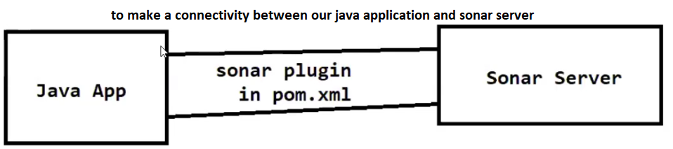
Add below 1 plug-in in project pom.xml file (in <build> tag)
search for sonar-maven-plugin in mvnrepository.com

<build> <plugins> <plugin>
<groupId>org.sonarsource.scanner.maven</groupId>
<artifactId>sonar-maven-plugin</artifactId>
<version>3.4.0.905</version>
</plugin>
</plugins> </build>
-> Do Maven build of project with below goal mvn clean compile package

-> For project do maven build with below goal To Do Code Review mvn sonar:sonar

-> After maven build completed, check sonar server dashboard.

-> We can see our project report under Projects
-> Report contains below details
1) Bugs(Blocker, Critical, Major & Minor)
2) Vunerabilities
3) Code Smells
4) Code Coverage 5) Duplicates etc...
For New Version of SonarQube >= 8.7 (In pom.xml)
<profiles>
<profile>
<id>sonar</id>
<activation>
<activeByDefault>true</activeByDefault>
</activation>
<properties>
<sonar.login>admin</sonar.login>
<sonar.password>admin123</sonar.password>
</properties>
</profile>
</profiles>

package com.cognizant.emps.constants;
public class AppConstants {
private AppConstants() {}
public static final String SEPARATOR="-----------------------------";
}

<dependency>
<groupId>log4j</groupId>
<artifactId>log4j</artifactId>
<version>1.2.17</version>
</dependency>

//Initializing the Logger object for current class
private static final Logger logger = Logger.getLogger(Main.class);

logger.info(AppConstants.SEPARATOR);

Realtime Workflow

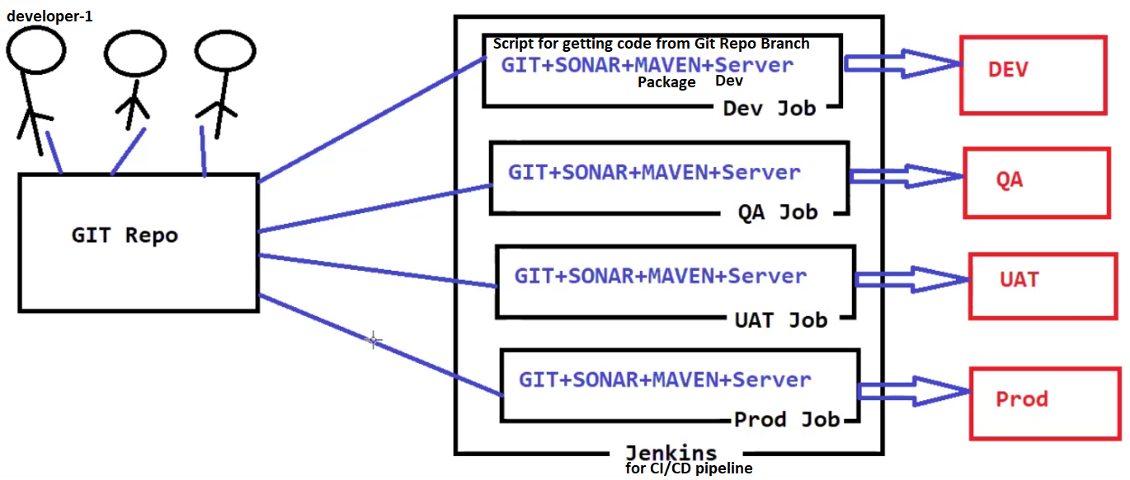
-> Every developer is responsible to perform code review in local machine once coding is completed.

-> Every developer should maintain sonar server in local so that we can perform code review in our local machine.

-> Once our code review completed we need to make sure Code Quality Gate is passed.

-> Once Code Quality Gate is passed, then we will push our code to GIT/BitBucket repository.

-> We will use Jenkins Jobs to deploy our application into environment specific server.

-> In Jenkins Job Sonar will be configured to perform Code Review.

PMD (Programming Mistake Detector)

PMD is a free source code analysis tool which helps you to find the bugs in your java code and improve the code quality.
PMD helps to find empty try/catch/finally statements, while/if statements, unnecessary object creation etc.
PMD warning and problems are not exactly errors, but shows that particular code need to be improved

Maven PMD plugin

<build>
<plugins>
<plugin>
<groupId>org.apache.maven.plugins</groupId>
<artifactId>maven-pmd-plugin</artifactId>
<version>3.14.0</version>
<configuration>
<linkXRef>true</linkXRef>
<sourceEncoding>utf-8</sourceEncoding>
<outputDirectory>reports/pmd</outputDirectory>
<targetDirectory>reports/pmd</targetDirectory>
</configuration>
</plugin> </plugins></build> Maven goal- pmd:pmd

